CSE3246 – Natural Language Processing (NLP)
Assignment Sheet
Total Marks: 20
- Presentation: 5 Marks
- Report Submission and Execution: 10 Marks
- Question Answer :5 marks

Instructions
- Attempt all questions and choose topic from the list below.
- Prepare a classroom presentation (PPT) explaining your approach, methodology, results, and analysis.
- Submit a soft copy of the report as per the below template.
- Each presentation should be 5–7 minutes followed by discussion or questions.
- Proper references must be included wherever datasets, libraries, or external resources are used.
- Plagiarism should be avoided; submissions must reflect original work.

Q1. Sentiment Analysis Mini Project
Tasks:
- Collect 20–30 product reviews.
- Perform:
  - Text preprocessing
  - Feature extraction BoW/(TF-IDF)
- Train a Naïve Bayes sentiment classifier.
- Show:
  - Accuracy
  - Confusion matrix
- Explain the results.

Q2. Word Embedding Similarity
Tasks:
- Use pre-trained Word2Vec or GloVe embeddings.
- Calculate cosine similarity for:
- king – queen
- doctor – nurse
- car – tree
- Write Python code for similarity computation.

Q3. Named Entity Recognition
Tasks:
- Use NLTK to perform NER on a news article.
- Identify entities:
  - Person
  - Organization
  - Location
- Visualize results.

Q4. Chatbot using NLP
Tasks:
- Build a simple intent-based chatbot using:
  - Python
  - NLP preprocessing
- The chatbot should answer queries about:
  - NLP concepts
  - AI applications
- Show sample conversations.
Consider the following for Solving above question:
1. Movie Review Sentiment Analysis
- Analyze positive, negative, and neutral sentiments from movie reviews.
- Dataset: IMDb or Kaggle movie review dataset.

2. Twitter Sentiment Analysis
- Analyze sentiment of tweets about a specific topic (e.g., elections, sports, or a brand).
- Use hashtags or keywords for data collection.

3. Product Review Analysis
- Classify sentiment from Amazon or Flipkart product reviews.
- Identify the most positively and negatively reviewed products.

4. Restaurant Review Sentiment Analysis
- Analyze customer feedback for restaurants.
- Identify common complaints and positive aspects.

5. Stock Market Sentiment Analysis
- Analyze financial news headlines or tweets about companies.
- Predict whether sentiment is positive, negative, or neutral.

6. Political Opinion Mining
- Analyze public opinion about government policies or elections using social media posts.

7. Emotion Detection from Text
- Detect emotions such as happy, sad, angry, surprise, fear instead of just positive or negative sentiment.

8. Multilingual Sentiment Analysis
- Perform sentiment analysis on English and Hindi reviews.
- Compare results between languages.

9. Sentiment Analysis of News Headlines
- Classify news headlines as positive, negative, or neutral.

10. Aspect-Based Sentiment Analysis
- Extract specific aspects from reviews.
Example:
“The camera quality is great but battery life is poor.”
Aspect results:
- Camera → Positive
- Battery → Negative

11. Emoji-Based Sentiment Detection
- Use emojis and emoticons to detect sentiment in social media posts.

12. Sarcasm Detection with Sentiment Analysis
- Identify sarcastic sentences where sentiment differs from literal meaning.
Example:
“Great! My phone battery died again.”

13. Customer Feedback Analysis
- Analyze customer feedback from service companies or apps.
- Identify areas of improvement.

14. Sentiment Analysis for Online Education Reviews
- Analyze feedback from students about online courses or platforms.

15. Chatbot Emotion Response System
- Build a chatbot that detects user sentiment and responds accordingly.

Tools Students Can Use
- Python
- NLTK
- TextBlob
- Scikit-learn
- HuggingFace Transformers
- spaCy

Format of NLP Report (Dataset Can be used from any resources):-

- Introduction of problem Statement - 1 page
- Highlight your contribution in 3 broad points . 1 page
- Dataset description in table and Visualization of dataset - 1 page
- Feature extraction (BoW, Tfidf, word embedding, sentence embedding, transformer)
- The algorithms (3 methods) used description (description along with equations , Flow Diagram of experimented methods) - 3 pages
- Hyperparameter description and Visualization of training process in graph (any two methods) - 1 pages
- Experimental Result (as mentioned in point A, evaluation measures) in form of table and graph visualization 2 pages

- Experimental Result and Evaluation Measures
To evaluate the effectiveness of the Machine Learning algorithms basic measures like Accuracy, Precision, Recall and F1-Measure (Han & Kamber, 2012) were adopted. Squared error based cost functions are inconsistent for solving classification problems. Also, these measures are widely used in domains such as information retrieval, machine learning and other domains that involve classification (Olson & & Delen, 2008). A confusion matrix is a base for the determination of these measures.
- Confusion Matrix
The confusion matrix can be represented as follows:

Table 2 Confusion Matrix
 |  | Predicted/Classified
 |  | Negative | Positive
Actual | Negative | True Negative (TN) | False Positive (FP)
 | Positive | False Negative (FN) | True Positive (TP)

Where –
True Positive (TP) = Number of positive instances correctly classified as positive.
False Positive (FP) = Number of positive instances incorrectly classified as negative.
True Negative (TN) = Number of negative instances correctly classified as negative.
False Negative (FN) = Number of negative instances incorrectly classified as positive
- Accuracy
Accuracy indicates the closeness of a predicted or classified value to its real value. The state of being correct is called Accuracy. It can be calculated as:
Accuracy= (TP+TN)/(TP+TN+FP+FN)

- Precision
Precision can be defined as the number of relevant items selected out of the total number of items selected. It represents the probability that an item is relevant. It can be calculated as:
Precision = TP/(FP+TP)
Precision is the measure of exactness.
- Recall
The Recall can be defined as the ratio of relevant items selected to relevant items available. The recall represents a probability that a relevant item is selected. It can be calculated as:
Recall = TP/(FN+TP)
The recall is the measure of completeness.
- F1-Measure
F1-Measure is the harmonic mean between Precision and Recall as described below:
F1-Measure= 2 * (Precision * Recall) / (Precision +Recall)
It creates a balance between precision and recall. Accuracy may be affected by class imbalance but F1 Measure is not affected by class imbalance. So with accuracy F1-measure is also used for evaluation of classification algorithms.
- Sensitivity
Sensitivity is used to find out the proportion of positive samples that are correctly identified also called a true positive rate. It is calculated as:
Sensitivity=TP/P
Where,
P = Total Number of Positive Samples
N = Total number of Negative Samples
- Specificity
Specificity is used to find out the proportion of negative samples that are correctly identified and also called a true negative rate. It is calculated as:
Specificity=TN/N
- False Positive Rate (FPR)
FPR is used to find out the proportion of negative samples that are misclassified as positive samples. It is calculated as:
FPR=FP/N
- False Negative Rate (FNR)
FNR is used to find out the proportion of positive samples which are misclassified as negative samples. It is calculated as:
FNR=FN/P
- Negative Predictive Value (NPV)
NPV is used to find out the number of samples which are true negative. It is calculated as:
NPV=TN/(TN+FN)
- False Discovery Rate (FDR)
FDR is also called an error rate. It is used to find out a proportion of false positive among all the samples that are classified as positive. It is calculated as:
FDR=FP/(FP+TP)
- Matthews’s correlation coefficient (MCC)
It is calculated as:
MCC=(TP*TN)-(FP*FN) /SQRT((TP+FP)(TP+FN)(TN+FP)(TN+FN))
MCC is a balanced measure based on a confusion matrix. This measure is used even if the classes are of different sizes. It is a correlation coefficient between the actual classes and predicted classes. The value of MCC lies between -1 to 1. The value near to +1 indicates the prediction is perfect. The value 0 indicates random prediction. The value -1 indicates a total disagreement between the actual and predicted values. MCC score above zero indicates balanced classification. MCC is a good measure when the data have varying classes, unbalanced dataset and random data (Jurman, Riccadonna, & Furlanello, 2012). With F1-score the MCC guides in a better way to determine the suitable algorithm for classification.

Results
The results for various evaluation measures for the various training percentages are indicated in figure 9, 10 and 11
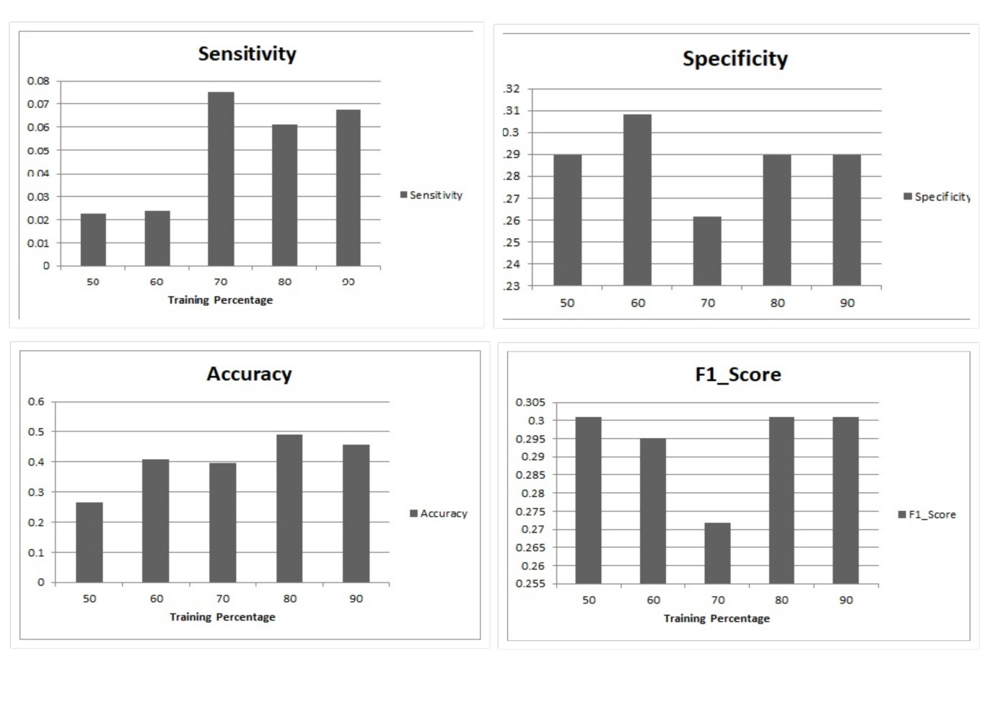
Figure 9 Results for Hybrid Model: Sensitivity, Specificity, Accuracy and F1_Score
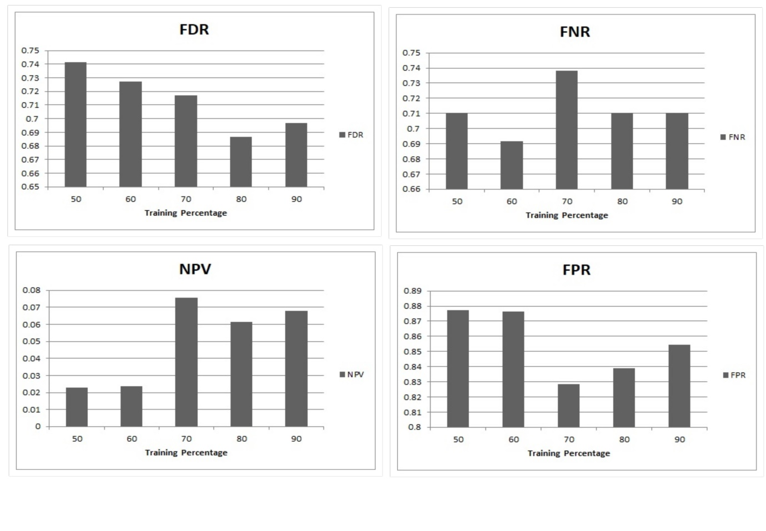
Figure 10 Results for Hybrid Model: FDR, FNR, NPV and FPR
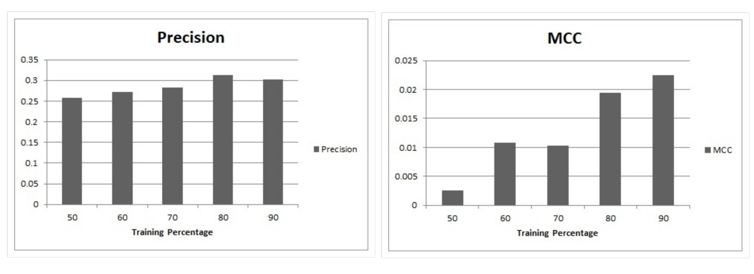
Figure 11 Results for Hybrid Model: Precision and MCC

The specificity of the hybrid model remains almost same to 0.85 for all training percentages. The sensitivity score is 0.80. The precision is also almost constant to 0.78 and is increased for 60% training.
The FPR is changing slightly from 0.18 to 0.20. For all training percentages, the ratio lies quite low from 0.03 to 0.06. The NPV score is good with an average value of 0.80. The FDR score is constant at 0.21 for different training percentages.
The accuracy graph shows a variation from 69% to 75% for different training percentages. The accuracy is good with 50% training. The accuracy has improved and is better than pure SVM and DBN for the considered data. The F1-score graph shows no variation in F1-score and it has a score of 0.81.
The MCC score also shows a variation with the values ranging from 0.13 to 0.18. The value of MCC score is far better than the MCC scores of SVM and DBN. The good and positive MCC score suggests that the proposed model is better suited for the data under consideration. There is a considerable improvement in MCC score indicating the suitability of the model for the educational data.
It is important to understand if the hybrid model is better than other models. It is necessary to look at evaluation measures to find the performance and suitability of the hybrid classification method for the collected educational data.
Table 3 Overall Performance of hybrid classification model over other methods
Algorithms→  Measures↓ | SVM | DBN | SVM with DBN
Specificity | 0.48 | 0.84 | 0.87
Sensitivity | 0.18 | 0.78 | 0.82
Accuracy | 0.65 | 0.7 | 0.76
Precision | 0.36 | 0.38 | 0.79
FPR | 0.83 | 0.23 | 0.19
FNR | 0.53 | 0.17 | 0.04
NPV | 0.18 | 0.78 | 0.82
FDR | 0.65 | 0.63 | 0.22
F1- Score | 0.41 | 0.54 | 0.82
MCC | 0.04 | 0.09 | 0.27

Note:- Maximum two members can work in single project.

